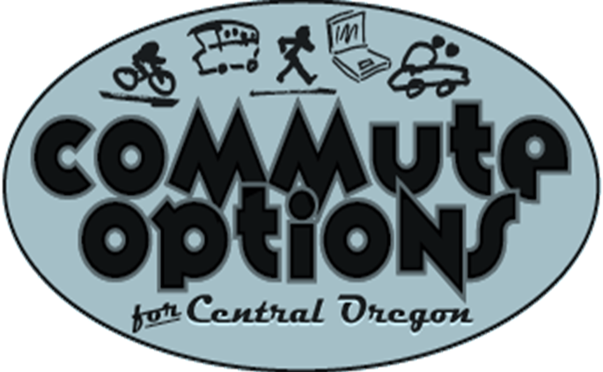

Commute Options Partner

Agreement

Commute Options Mission:
Promote transportation choices that reduce the impacts of driving alone. The energy of the partners will be used to educate and inspire employees to take the steps necessary to change personal travel behavior.
Purpose and Goal:
The purpose of this Agreement is to create and define a working partnership among employers and Commute Options in the pursuit of a shared goal. The Agreement defines the procedures for Commute Options and the partners.
Commute Options Commitment:
Commute Options will work one-on-one with employers to develop a customized transportation plan, reward employees using commute options, and provide presentations, brochures, posters and materials, and a website promoting smart commuting choices.
Commute Options provides a free online service called Drive Less Connect. The program offers the following services to Commute Options Partners.
- Drive Less Connect makes it easy for employees to log and track trips. The site also lets employees know how much money they’ve saved and the positive impact they’ve had on reducing the affect driving alone has made in their community.
- Drive Less Connect helps users match up in carpools, find other bicyclists to ride with or get info on riding the bus.
- Drive Less Connect automatically submits rewards requests for employees of Partners that participate in the Rewards Program.
- Drive Less Connect allows Commute Options to quickly provide information about current and future programs and events.
- Employees register for Drive Less Connect using : https://drivelesssavemore.icarpool.com/en/Login.aspx

Commute Option Partner Commitment:
The Commute Options Partner agrees to use the resources provided by Commute Options to educate and encourage their employees to walk, bike, carpool, vanpool, bus or telework instead of driving alone to work.
The Partner agrees to select an employee to serve as the Employee Transportation Coordinator (ETC). The ETC represents the employer and participates in Commute Options activities, including training, the Commute Options Week Challenge, and other promotional events.
There is no cost to partners that choose not to participate in the Rewards Program.
Commute Options Partner Rewards Program:
- Partners can choose to participate in the COP Rewards Program. The program awards a $20 gift card to employees that commute to work 45 days using a commute option. Drive Less Connect automatically submits rewards requests for employees of Partners that participate in the Rewards Program.

COPs that participate in the Rewards Program contribute funding to Commute Options based on the scale below. Additional funding may be requested from individual employers that have a large demand for certificates.
Number of Employees Amount
Under 5 & $50
6 - 20 $75
21 – 100 $100
101 – 200 $150
201 – 500 $200
Over 500 $300

Term of the Agreement:
The Agreement is effective the date signed through December 31, 2012 and shall be renewed annually.

Commute Options Partner (COP) Commute Options
COP:___________________________
Date:___________________________ Date:______________________________
By:_____________________________ By:________________________________
Contact (ETC):____________________ Contact: Jeff Monson, Executive Director
Phone:__________________________ Phone: 541-330-2647_______________
Email:__________________________ Email: jeff@commuteoptions.org____
Address:________________________ Address: 50 SW Bond St., Suite 4___
_______________________________ _________Bend, OR 97701____________
Total Number of Employees:________

